**ASSIGNMENT 2**

12/10/2022

STATISTICS AND TRENDS

Global Climate Factors.

hamzanaseer566@gmail.com

**muhammad Hamza naseer (21088910)**

**GLOBAL CLIMATE FACTORS- ADS2**

**INTRODUCTION**

This report is mainly based on understanding the different economic and climate relation indicators of the countries in the world. We would find out the descriptive statistics of the different indicators and we would also focus on the trend analysis of the different indicators. We would also perform an analysis on an inter-country level which would help us to identify the association between different indicators of a particular nation.

**ANALYSIS**

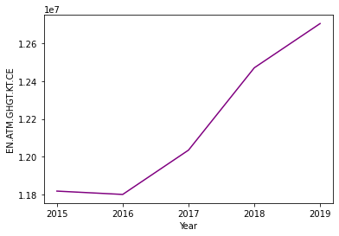 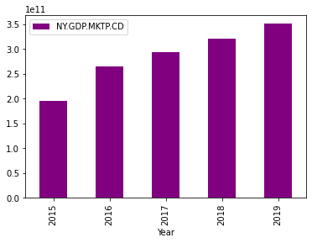

The Line plot visualization for Emissions of Greenhouse gases in China indicates that the numbers were almost equal for 2015 and 2016 but it shows an increasing trend during the timeframe of 2016 to 2019

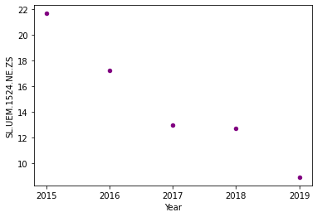

The Scatter plot visualization for the youth unemployment in Bulgaria indicates that there is a decreasing trend during the timeframe of 2015 to 2019

The Bar plot visualization for the current market GDP in Bangladesh indicates that there is an increasing trend during the timeframe of 2015 to 2019

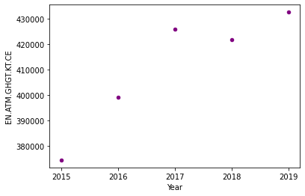

The scatter plot visualization for greenhouse gas emission in Pakistan indicates that there is an increasing trend during the timeframe of 2015 to 2019

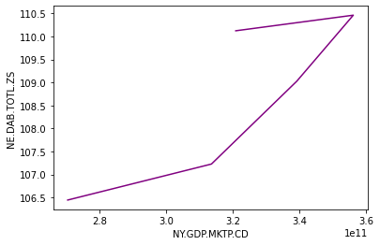 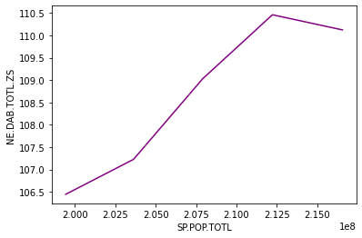

The correlation analysis on an inter-country level for Pakistan shows that the relationship between the current GDP and current expenditure in Pakistan is direct in nature

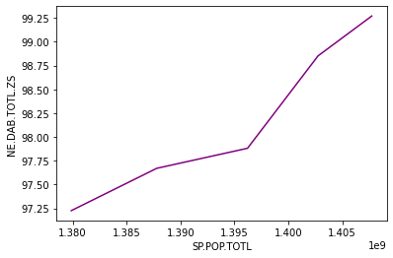

The correlation analysis on an inter-country level for China shows that the relationship between total population and the current expenditure in China is direct in nature

**CONCLUSION**

* The Emissions of Greenhouse gases in China has shown an increasing trend from 2015 to 2019
* The current market GDP in Bangladesh has shown an increasing trend from 2015 to 2019
* The youth unemployment in Bulgaria has shown a decreasing trend from 2015 to 2019
* The greenhouse gas emission in Pakistan has shown an increasing trend from 2015 to 2019

The correlation analysis on an inter-country level for Pakistan shows that the relationship between the relationship between the total population and current expenditure in Pakistan is direct in nature

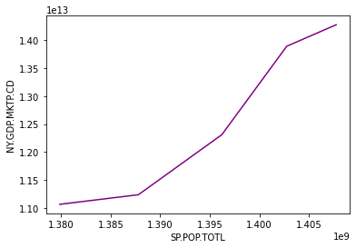

The correlation analysis on an inter-country level for China shows that the relationship between total population and the current GDP in China is direct in nature

* The inter- country level analysis for Pakistan has showed that there exits a direct relationship between the current GDP and current expenditure. Also, there is a direct relationship between the total population and current expenditure in Pakistan
* The inter- country level analysis for China has showed that there exits a direct relationship between total population and the current expenditure. Also, there is a direct relationship between the total population and the current GDP in China